OPTICS & PHOTONICS International Exhibition 2017
  - Press Release

Phoseon Technology Exhibits LED Curing Solutions at
OPTICS & PHOTONICS International Exhibition 2017
Visit the Phoseon booth F-27 to learn more about LED industrial curing
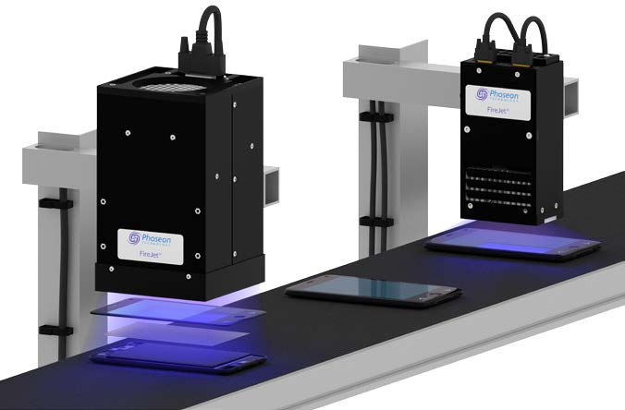
Hillsboro, Oregon (March 17, 2017) – Phoseon will showcase the latest UV LED curing solutions for industrial applications at the upcoming OPTICS & PHOTONICS International Exhibition 2017, which including the OPIE 2017 and IR+UV Expo in Yokohama, Japan. Visit the Phoseon exhibit, booth number F-27, to learn how Phoseon LED technology is a perfect fit for industrial curing applications due to the compact size, ease of integration, and high intensity output achieved through optimized LED thermal management. Users of Phoseon LED curing systems can process a variety of materials, including thin and heat-sensitive substrates, at maximum production speeds with low-input power.
OPTICS & PHOTONICS International Exhibition 2017 will take place at the Pacifico Yokohama Conference Center on April 19-21 in Yokohama, Japan. It will showcase a wide variety of UV industry-related equipment, manufacturing machinery, drying and curing equipment associated with this sector. OPIE 2017 and IR+UV Expo are co-located with LASER EXPO, LENS EXPO, Positioning EXPO, Medical & Imaging EXPO, Space & Astronomical Optics EXPO and Industrial Camera EXPO.

About Phoseon Technology
In 2002, Phoseon Technology pioneered the use of LED technology for UV curing applications, and has recently expanded into Life Sciences. As the world leader in providing UV LED solutions, Phoseon engineers patented LED technology to deliver rugged, high-performance products for application specific needs. The company is focused 100% on LED technology and provides worldwide sales and support capabilities.

CONTACT:
Kazuhiro Tanaka
General Manager
Phoseon Technology Japan K.K.
+81-70-1423-2300
japan@phoseon.com
www.phoseon.jp

##

